7.32: a) 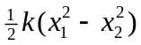 b)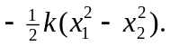 The total work is zero; the spring force is conservative c) From 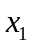 to 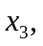 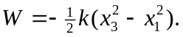 From  to 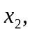 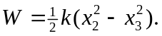 The net work is 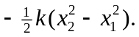 This is the same as the result of part (a).

